Warwick Valley High School Crew Team
warwickcrewboosterclub@gmail.com
http://www.wvhsrowing.org

2023-2024 SPONSOR REQUEST

The 100% self-funded Warwick Valley High School Crew Team needs your help!
The WVHS Crew Team has won numerous gold medals over the course of the past 5 years at Scholastic State Championships in Saratoga. Most recently, 2023 NY State Champions Girls Straight 4, Silver Medal Girls Freshman 8, and Bronze Medal Boys Straight 4. HVRL Champions in both 2017, 2018 & Girls 2023 HVRL Champions.
The WVHS Crew Team is extremely fortunate to have two coaches that are world class rowing professionals from Greenwood Lake - a married team, the Codys. The coaches volunteer their time and share their love and dedication for rowing with the team throughout the entire year. Improving the teams equipment, purchasing new shells, and having an erg available at practice for each rower would ensure that each rower gets the training they need on and off the water.
Rowing is considered a club sport in the Warwick Valley Central School District, and as such Warwick Crew is 100% self-funded. The team relies on athlete rowing fees, fundraisers and donations to sustain operations which can easily amount to over $15,000 per year in basic expenses without the consideration of new equipment - a used shell costs $10,000 - $15,000!
The WVHS Crew Team was founded in 2003 and is a competitive year round rowing program that welcomes all students from Warwick Valley High School, in Warwick, NY. The team practices on Greenwood Lake in the fall and spring. During the winter, indoor practice takes place on ergs at Warwick Valley High School.
Crew recognizes and promotes teamwork to achieve a goal (over individual achievement), promotes self-confidence, academic excellence, healthy living, leadership, and positive communication skills - all qualities that are extremely important throughout life and business.
Please consider donating to the WVHS Crew Team to help our student athletes reach their goals.
Enclosed you will find information detailing various sponsorship levels. The team is grateful for any support you can provide!
To see the team in action please enjoy the WVHS Crew Team 2019 Music Video by Paul Romano Productions
https://www.youtube.com/watch?v=B_CEk_HL4fc&t=2s
Sincerely,
The Warwick Crew Booster Club
Warwick Valley High School Crew Team
warwickcrewboosterclub@gmail.com
http://www.wvhsrowing.org

2023-2024 SPONSORSHIP TIERS
Please pull for us - and promote your business at the same time!
Warwick Crew competes in regattas not only throughout the Hudson Valley, but also regionally, and are attended by hundreds of people and up to 20-50 schools at a time, providing high visibility for your business. Your annual sponsorship would be seen at each of our 8-10 regattas during the fall and spring seasons!
Gold sponsor: $1000
- Business logo on team trailer
- Business logo on team food tent banner
- Plaque with team photo and recognition as a 2023-2024 WVHS Crew Sponsor
- Business name will appear on the team T-Shirt
- Your business name featured on our website, along with a link to your website
- Recognition on Warwick High School Crew Social Media Pages
Silver Sponsor: $500
- Business logo on team food tent banner
- Plaque with team photo and recognition as a 2023-2024 WVHS Crew Sponsor
- Business name will appear on the team T-Shirt
- Your business name featured on our website, along with a link to your website
- Recognition on Warwick High School Crew Social Media Pages
Bronze Sponsor $300
- Business logo on team food tent banner
- Business name will appear on the team T-Shirt
- Your business name featured on our website, along with a link to your website
- Recognition on Warwick High School Crew Social Media Pages
Family & Friends - any donation is greatly appreciated!
*The deadline for accepting logo artwork for the banner and team t-shirts will be February 1, 2024 for initial printing but accommodations will be made for agreements received after that date.

— SOME EXAMPLES OF HOW WE WILL FEATURE YOUR BUSINESS —

Example of Trailer:
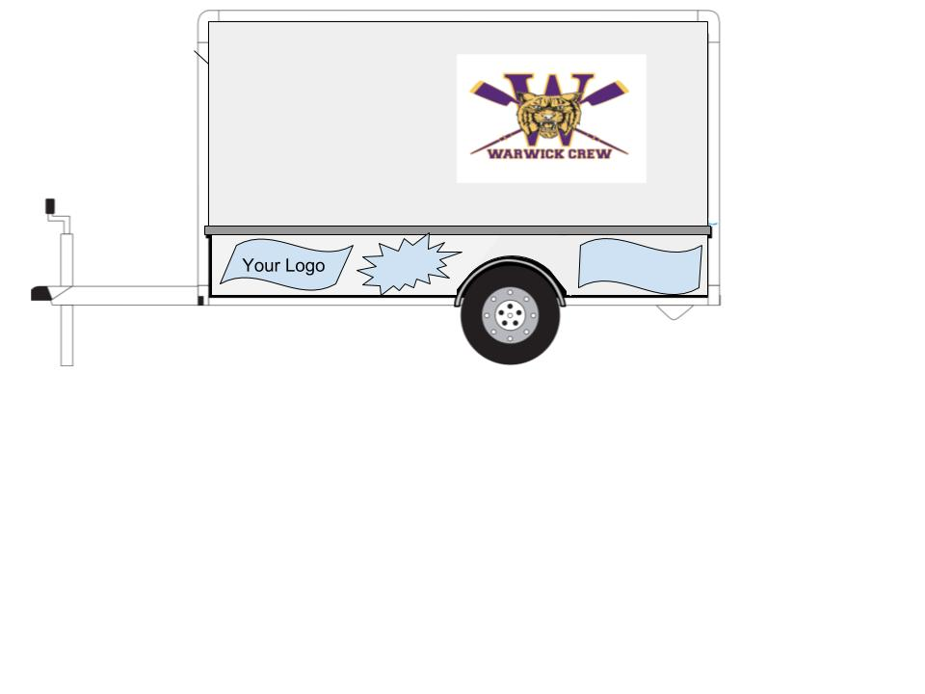
Example of Team Food Tent Banner:
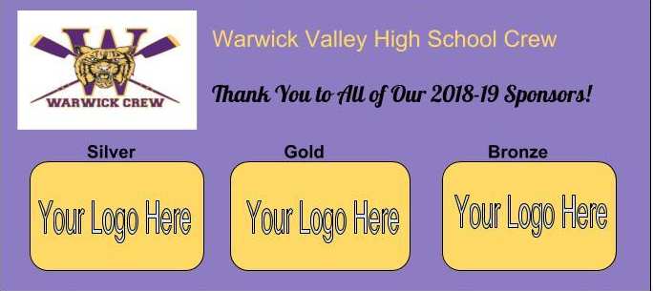

We welcome the opportunity to speak with you further to provide you with
additional details or options if needed. Please contact:
warwickcrewboosterclub@gmail.com

Warwick Valley High School Crew Team
warwickcrewboosterclub@gmail.com
http://www.wvhsrowing.org

2023-2024 SPONSOR FORM

Business Name _________________________________________________________________

Address ______________________________________________________________________

City _____________________________ State __________________ Zip ___________________

Contact Person _____________________________ Contact Phone # ______________________

Contact Email ___________________________________________________________________

Sponsor Tier _____________________________ Amount Enclosed _______________________

Signature______________________________________________________________________
By signing, I agree that I am authorized to make contributions on behalf of my business or organization

Please email us at warwickcrewboosterclub@gmail.com with any questions.
Checks are payable to Warwick Crew and can be mailed to:
Warwick Crew Team
P.O. Box 252
Warwick, NY 10990

Please email logo artwork to: warwickcrewboosterclub@gmail.com

Business FaceBook Page__________________________________________________________

Business Website Address_________________________________________________________

*The Warwick Crew Team is supported by the Warwick Crew Booster Club, a 501(c)(3) non-profit organization, therefore your contribution is tax deductible to the extent of IRS Regulations and is greatly appreciated by the rowers!

Thank you for supporting the Warwick Valley High School Crew Team!

